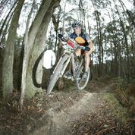

Phil Crothers Clubperson Award
Nomination Form

The Phil Crothers Clubman Award is awarded to a person or persons at the end of each LMBC race season that has exhibited behaviours that supports the endeavors of the Launceston Mountain Bike Club. As a founding member of LMBC, Phil contributed to the sport and club in many ways, as was his love of the sport.
Nominations are open to all financial members of the club (past & present) and need to be in writing using this official nomination form only. Nominations close on the 1 March each year and need to be returned to the club by email or PO Box. Nominators and seconders need to be financial members of the club unless approved by the committee.
Information about Phil, his contribution to LMBC and the community can be found at
The Committee’s decision is final and will be announced at the completion of LMBC’s final race of the season. This is currently the Forestry Tasmanian King & Queen of the Mountain.

Nominator’s Details
Name
Address
Mobile
Email
Relationship to Nominee
Date

I would like to nominate _______________________________________________________ for the
Phil Crothers Clubperson Award.

Please provided the reasons why you would like to nominate this person for the LMBC / Phil Crothers Clubperson Award.

Please email to lmbcinfo@gmail.com

